Chapter 20: Comparing Groups

1. **Confidence Interval for the Difference Between Two Proportions:**

**Seat-Belt Example:**

1. Open a new excel sheet.
2. Using the textbook example: sample size for men (n) = 4208, sample size for women (m) = 2763, successes in men $\left(X_{1}\right)$ = 2777, successes in women $\left(X_{2}\right)$ = 1363 and construct a 95% confidence interval.

|  |  |
| --- | --- |
| Sample Size Group 1 (n) | = 4208 (given) |
| Successes in Group 1 (X1) | = 2777 (given) |
| Proportion Group 1 (p1) |  |
| $$q_{1}=1-P_{1}$$ |  |
| Sample Size Group 2 (m) | = 2763 (given) |
| Successes in Group 2 (X2) | = 1363 (given) |
| Proportion Group 2 (p2) |  |
| $$q_{2}=1-P_{2}$$ |  |
| Confidence Level (1 - α) | = 0.95 (given) |
| Significant level (α) |  |
| SD (p1-p2) |  |
| Critical Values (Z*) |  |
| Lower Confidence Level (L) |  |
| Upper Confidence Level (U) |  |

1. Use **NORM.S.INV** function to calculate critical values of normal distribution.



where **Probability** is the probability corresponding to the normal distribution.

1. The result is

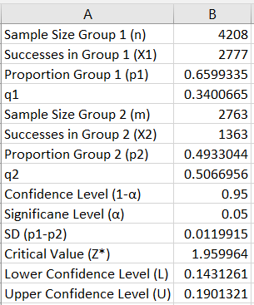

The 95% confidence interval is (0.143, 0.190)

1. **Testing for the Difference Between Two Proportions:**

**Sleep Example:**

1. Open a new excel sheet.
2. Using the textbook example: sample size for men (n) = 4208, sample size for women (m) = 2763, successes in men $\left(X_{1}\right)$ = 2777, and successes in women $\left(X_{2}\right)$ = 1363.

Are the pre-sleep surfing rate or the two groups really different?

|  |  |
| --- | --- |
| Sample Size Group 1 (n) | = 4208 (given) |
| Successes in Group 1 (X1) | = 2777 (given) |
| Proportion Group 1 (p1) |  |
| Sample Size Group 2 (m) | = 2763 (given) |
| Successes in Group 2 (X2) | = 1363 (given) |
| Proportion Group 2 (p2) |  |
| Pooled sample proportion (p-pooled) |  |
| q (pooled) |  |
| SD (pooled) |  |
| Significant level (α) | = 0.05 (given) |
| Z score |  |
| P-value |  |

Note: the functions were used in chapter 7.

1. The result is

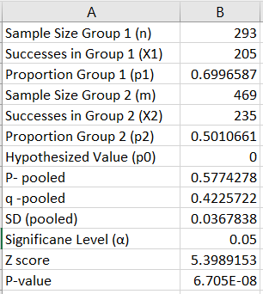

**Note:**

1. If $H_{a}:P_{1}<P_{2}$, then use P-value = NORM.S.DIST (z, True)
2. If $H_{a}:P_{1}>P_{2}$, then use P-value = 1 - NORM.S.DIST (z, True)
3. If $H_{a}:P_{1}≠P_{2}$, then use P-value = 2 (1 - NORM.S.DIST (ABS(z), True))

**Note:** **ABS** function returns the absolute value of a number.

1. **Confidence Interval for the Difference Between Two Means:**

**Soup Bowls Example:**

1. Open a new excel sheet.
2. Using the textbook example: sample size for ordinary bowl (n) = 27, sample size for refilling bowl (m) = 27, successes in men $\left(X_{1}\right)$ = 2777, successes in women $\left(X_{2}\right)$ = 1363 and construct a 95% confidence interval.

|  |  |
| --- | --- |
| Sample Size Group 1 (n) | = 4208 (given) |
| Successes in Group 1 (X1) | = 2777 (given) |
| Proportion Group 1 (p1) |  |
| Sample Size Group 2 (m) | = 2763 (given) |
| Successes in Group 2 (X2) | = 1363 (given) |
| Proportion Group 2 (p2) |  |
| Pooled sample proportion (p-pooled) |  |
| q (pooled) |  |
| SD (pooled) |  |
| Significant level (α) | = 0.05 (given) |
| Z score |  |
| P-value |  |

Note: the functions were used in chapter 7.